**BookScape Explorer Pro**

**A Digital Library & Book Recommendation System**

1. **Introduction:**

**BookScape Explorer Pro** is an end-to-end, data-driven book discovery and analysis platform built with **Streamlit**, **MySQL**, and the **Google Books API**. Designed for book enthusiasts, librarians, and bookstore managers alike, it allows users to search, analyse, and visualize book metadata in powerful new ways.

With just a few clicks, you can fetch live book data from Google’s vast digital catalogue, store it locally in a structured MySQL database, and generate actionable insights through intuitive dashboards. Whether you're exploring literary trends, evaluating top publishers, or discovering hidden gems, BookScape gives you the tools to make smarter decisions with clean, reliable data.

**Key Features:**

* Google Books API integration
* MySQL database storage
* Advanced search filters
* Data visualization and trend analysis
* Community features

Whether you're a bookstore chain seeking market insights, a librarian digitizing your inventory, or a developer building your next book app, **BookScape Explorer Pro** is your analytical foundation.

1. **2· Project Objectives**

The BookScape Explorer project aims to streamline the retrieval and storage of comprehensive book metadata from the Google Books API through an automated ETL pipeline, ensuring data consistency with validation checks and duplicate handling.

It provides business-centric analytics, including inventory optimization and market trend analysis, through 20+ predefined SQL queries tailored for book retailers, libraries, and collectors

1. **High‑level Architecture**

User → Streamlit UI → Google Books REST API

↓ ↓

MySQL Connection Pool ← JSON

↓

books table (RDBMS)

↓

Query Explorer • Trend Dashboards • Exports

1. **Project flow diagram:**

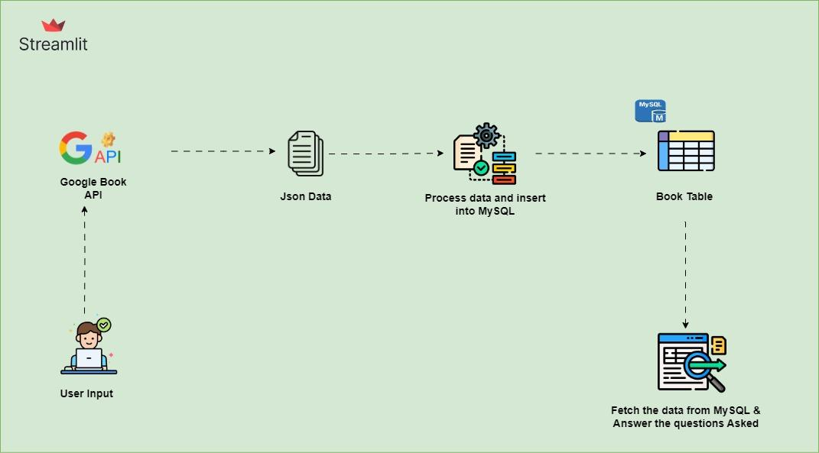

**5.Setup Instructions**

**Prerequisites**

* **Python ≥ 3.9**
* **MySQL 8.x** (local or remote)
* Google Cloud project with a **Books API key**
* **Frontend/UI**: [Streamlit](https://streamlit.io/)
* **Python Libraries**: requests, pandas, mysql-connector-python, plotly, python-dotenv

**MySQL credentials:**

DB Host=localhost

DB User=root

DB Password=admin

DB Name=bookscape

Google Books API🡪GOOGLE_BOOKS_API_KEY=xxxxxxxxxxxxxxxxxxxxxxxxxxxxxx

* 1. **Project Detailed steps:**
* Created a new project on Google Cloud Console and enabled the Google Books API to get the credentials and API key.
* Then table is created if the table doesn’t exist.
* Once the search option gets triggered, it will fetch the data from google books api and saved to MySQL.
* Based on the queries database gives the result

**Demo Walk‑through**

This walkthrough shows how to use the app from scratch, covering search, import, analysis, and insights.

**✅ Step 0: Launch the App**

streamlit run bookscape_app.py

**🏠 Step 1: Home Page**

* Visit: [**http://localhost:8501**](http://localhost:8501)
* See the welcome screen with a project description and usage guide.
* Confirm sidebar shows: ✅ *Connected to MySQL (pool)*

**🔍 Step 2: Basic Search & Import**

1. Go to **“Basic Search”** in the sidebar.
2. In the search box, type: Ex. machine learning

3. Set **Max Results** to 50.

4. Click **Search & Import**.

The app fetches results from the Google Books API, displays them in a table, and shows a success message.

1. You’ll get a message **💾 Saved to Database**.

**🎯 Step 3: Advanced Search**

* 1. Go to **“Advanced Search”**.

3.2. Fill in:

* + Title: deep learning
  + Author: Ian Goodfellow
  + Genre: Artificial Intelligence
  + Year: 2016
  + Min Rating: 4.0
  + Min Pages: 200
  1. Click **Search**.

Behind the scenes, this builds a query like:

SELECT * FROM books

WHERE title LIKE '%deep learning%' AND authors LIKE '%Ian Goodfellow%'

AND categories LIKE '%Artificial Intelligence%'

AND published_year = '2016'

AND average_rating >= 4.0 AND page_count >= 200

LIMIT 500

* 1. Results will show in a searchable table.

**📊 Step 4: Query Explorer**

1. Navigate to **“Query Explorer”**.
2. Select a predefined query:

Ex. Check Availability of eBooks vs Physical Books

1. Click Run Query.

**📈 Step 5: Trend Analysis**

1. Go to “Trend Analysis”.
2. Choose tab: Genre Trends, Author Popularity, or Publication Trends.
3. Drag the year range slider to focus on specific decades.
4. Watch line charts, scatter plots, and bar graphs update instantly.

**💡 Step 6: Data Insights**

1. Go to “Data Insights”.
2. Open the first expander: 📊 Inventory Recommendations
   * Shows top-rated books with >1,000 reviews.
   * Option to Download CSV.
3. See 📈 Market Analysis for top & emerging categories.
4. Analyse Rating vs Price breakdown (free vs paid).

**👥 Step 7: Community and Statistics**

* Post a comment about what you’re reading.
* View community stats:
  + Total books
  + Monthly visitors

**🔚 Step 8: Close the App**

* Press Ctrl+C in your terminal to stop the Streamlit server.
* All data is safely stored in your MySQL bookscape database.

========================= End ===========================